Dokumentacija Sajt

Shooper

Filip Radosavljevic 74.18

Contents

1.Opis 3

2. Skica baze podataka 6

3.Strukrura fajlova 7

4.Kodovi 8

4.1Index.php 8

4.2Register.php 9

4.3Pocetna.php 11

4.4 Prodavnica.php 12

4.5 Proizvod detalj.php 13

4.6 Meni.php 16

4.7 Footer.php 17

4.8 Izmeni.php 17

4.10 Admin.php 21

4.11 Autor.php 25

4.12 Main.js 26

4.13 Shop.js 27

4.14Admin.js 30

4.16 Svetabele.php 33

4.17 Registrovanje.php 33

4.18 Prodavnicamodels.php 35

4.19 Pocetnaproizvod.php 36

4.20 Order.php 36

4. 21 Obrisi proizvod.php 37

4.22Obrisi Korisnika 38

4.23 Logovanje.php 38

4.24 Logout.php 39

4.25 Logfajl.php 39

4.26 Izmeniproizvod.php 40

4.28 ExportWord.php 41

4.29 DodajProizvod.php 41

4.30 AdminModul.php 43

4.31 Config.php 44

4.32 Connectiom.php 44

# 1.Opis

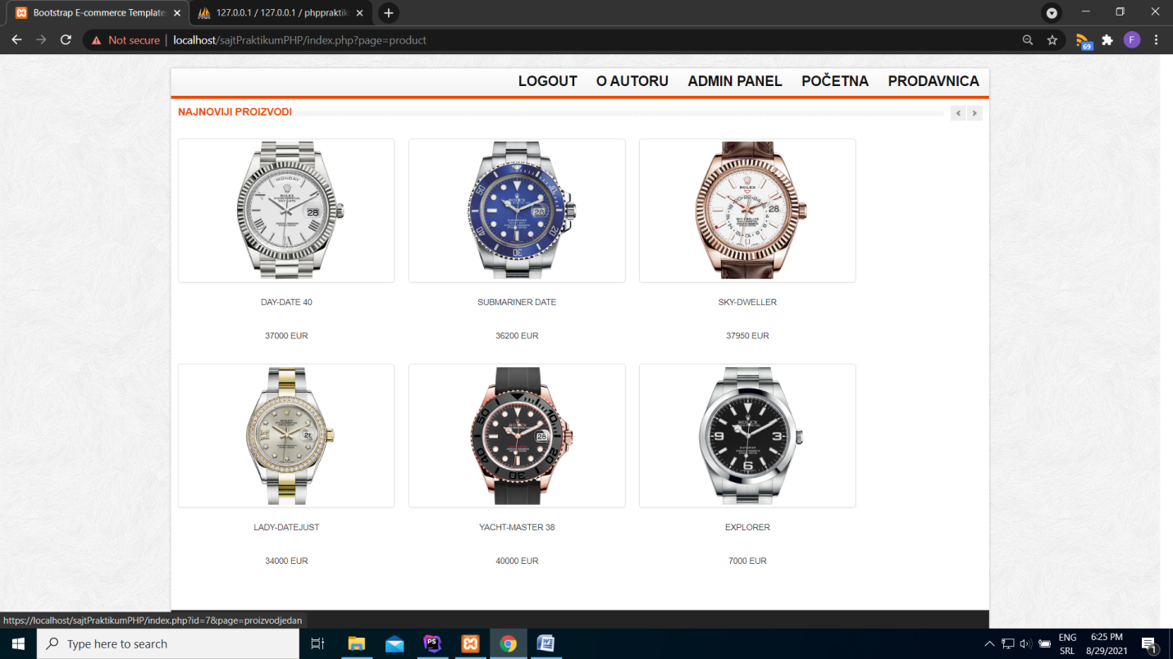

Početna strana prikazuje 6 najnovijih proizvoda.Sajt takodje ima I dinamički meni učitan iz baze podataka.Tamplate je preuzet sa interneta.

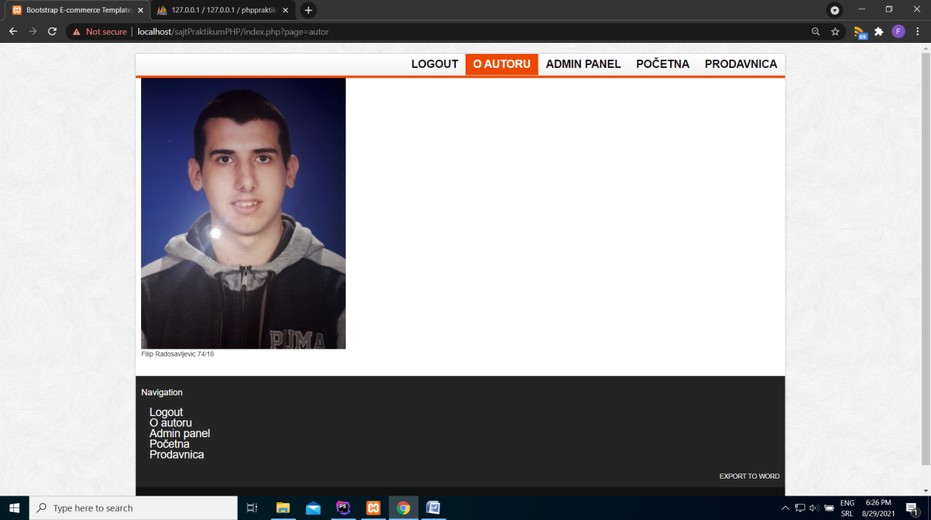

Stranica o autoru.

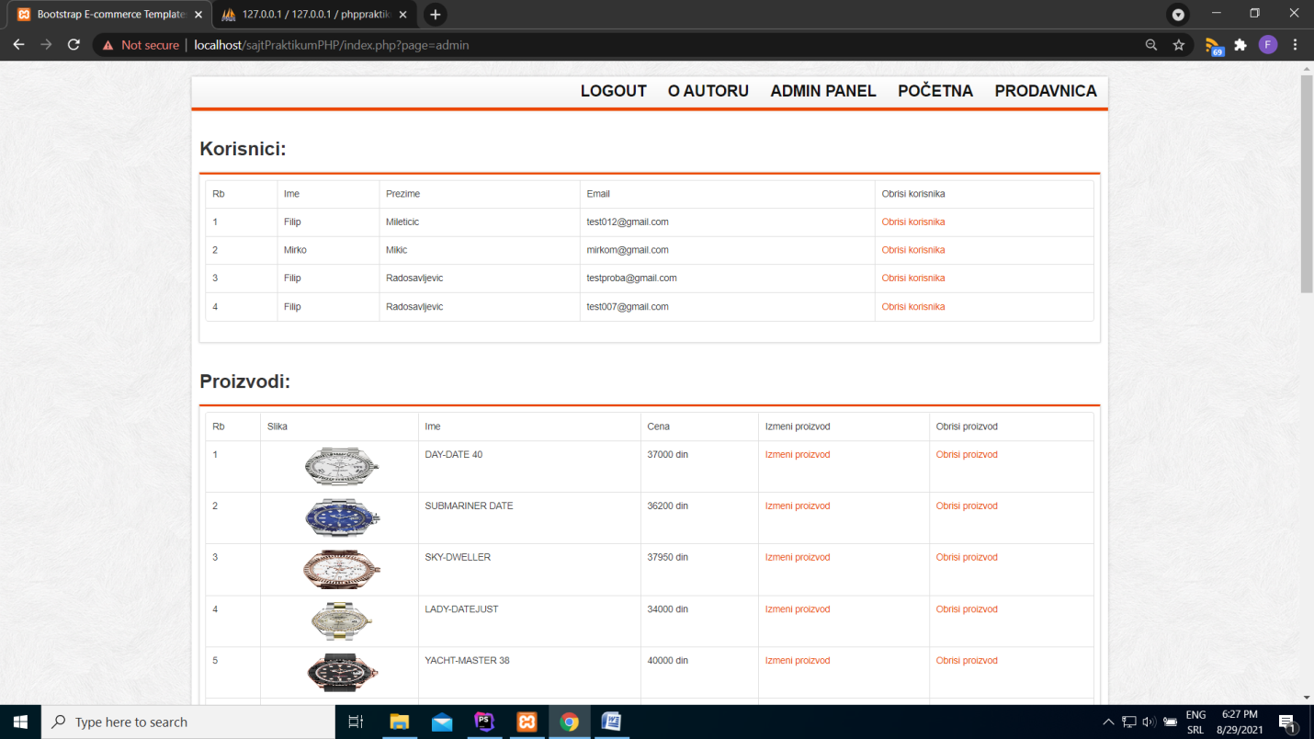

Admin panel za upravljanje sadržajem celog sajta.

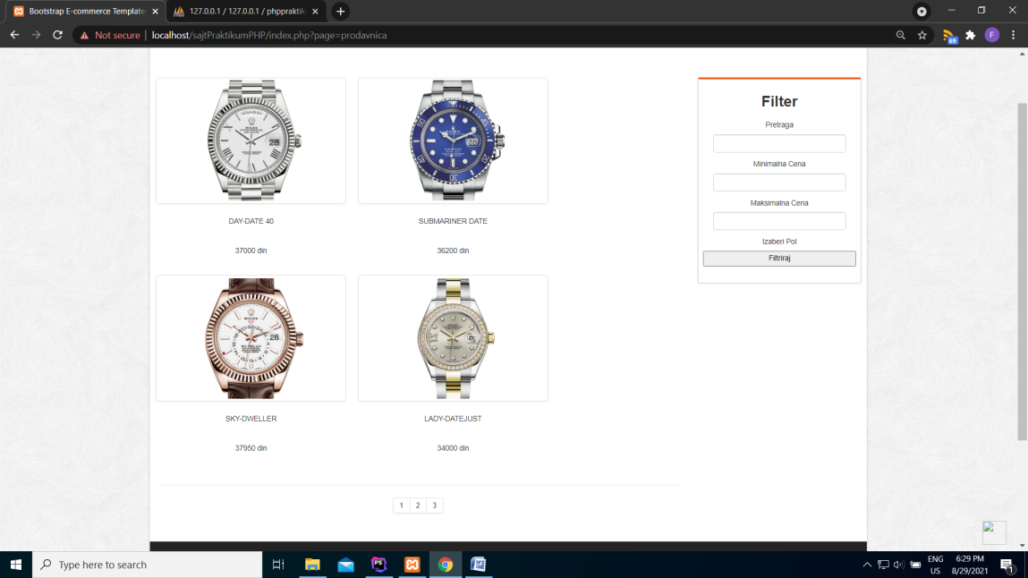

Prodavnica koja sadrzi paginaciju I filtriranje I prikazuje proizvode putem ajaxa.

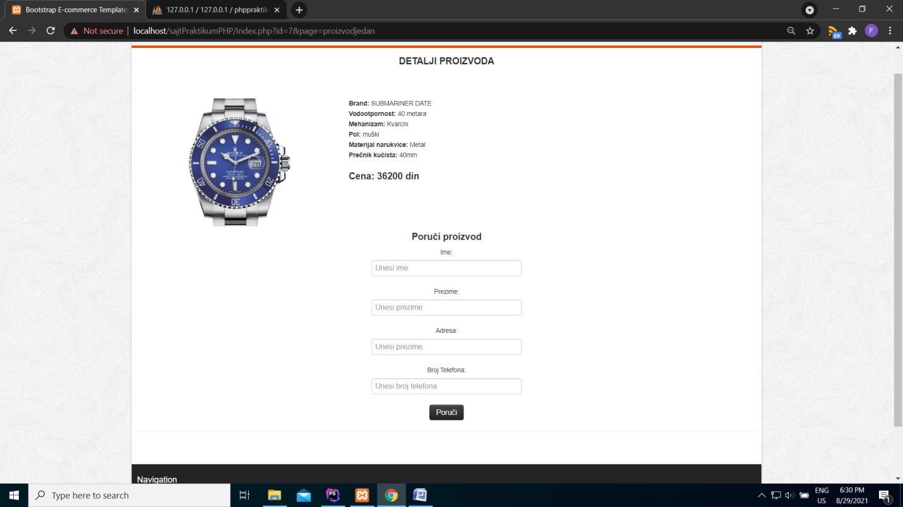

Stranica o jednom proizvodu sa formom za porucivanje.

# 2. Skica baze podataka

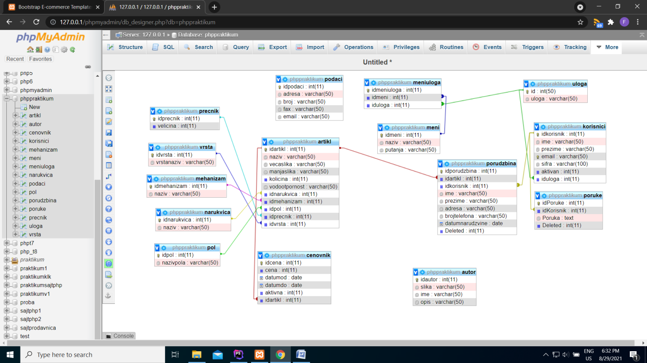

# 3.Strukrura fajlova

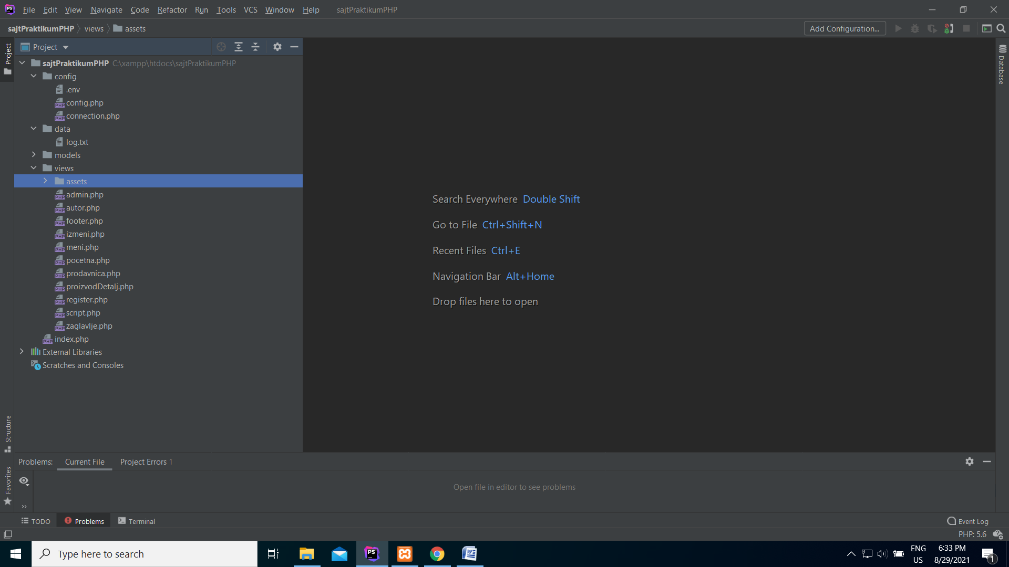

# 4.Kodovi

## 4.1Index.php

<?php  
ob_start();  
session_start();  
?>  
<!doctype html>  
<?php include "config/connection.php"; ?>  
<html lang="en">  
<?php include"views/zaglavlje.php"; ?>  
<body>  
<div id="wrapper" class="container">  
 <?php  
 include "views/meni.php";  
 //include "views/pocetna.php";  
 //include "views/register.php";  
 //include "views/prodavnica.php";  
 // include "views/proizvodDetalj.php";  
 if(!isset($_GET['page'])){  
 include "views/pocetna.php";  
 }  
 else {  
 switch($_GET['page']){  
 case 'prodavnica':  
 include("views/prodavnica.php");  
 break;  
 case 'admin':  
 include("views/admin.php");  
 break;  
 case 'logout':  
 include("models/logout.php");  
 break;  
 case 'autor':  
 include("views/autor.php");  
 break;  
 case 'proizvodjedan':  
 include("views/proizvodDetalj.php");  
 break;  
 case 'register':  
 include("views/register.php");  
 break;  
 case 'izmeni':  
 include("views/izmeni.php");  
 break;  
 default:  
 include("views/pocetna.php");  
 break;  
 }  
 }  
  
 include "views/footer.php";  
 ?>  
</div>  
<?php include "views/script.php"; ?>  
</body>  
</html>

# 4.2Register.php

<?php  
zabeleziPristupStranici('login');  
?>  
  
<section class="main-content">  
 <div class="row">  
 <div class="span5">  
 <h4 class="title"><span class="text"><strong>Uloguj se</strong></span></h4>  
 <form action="models/logovanje.php" method="post">  
 <input type="hidden" name="next" value="/">  
 <fieldset>  
 <div class="control-group">  
 <label class="control-label">Username</label>  
 <div class="controls">  
 <input type="text" placeholder="Unesi username" id="email" name="email" class="input-xlarge">  
 </div>  
 </div>  
 <div class="control-group">  
 <label class="control-label">Password </label>  
 <div class="controls">  
 <input type="password" placeholder="Unesi password" id="email" name="sifra" class="input-xlarge">  
 </div>  
 </div>  
 <div class="control-group">  
 <input tabindex="3" class="btn btn-inverse large" type="submit" name="logindugme" value="Uloguj se">  
 <hr>  
  
 </div>  
 </fieldset>  
 </form>  
 <ul>  
 <?php  
 if(isset($_SESSION['greskalogin'])):  
 ?>  
 <li><?=$_SESSION['greskalogin']?>  
 <?php unset($_SESSION['greskalogin']);  
 ?>  
 <?php endif;?>  
 <?php  
 if(isset($_SESSION['greskalogovanje'])):  
 foreach($_SESSION['greskalogovanje'] as $g):?>  
 <li><?=$g?></li>  
 <?php unset($_SESSION['greskalogovanje']);?>  
 <?php  
 endforeach;  
 endif;  
 ?>  
 </ul>  
  
 </div>  
 <div class="span7">  
 <h4 class="title"><span class="text"><strong>Registracija</strong></span></h4>  
 <form action="models/registrovanje.php" method="post" class="form-stacked">  
 <fieldset>  
 <div class="control-group">  
 <label class="control-label">Ime</label>  
 <div class="controls">  
 <input type="text" placeholder="Unesi ime" name="ime" class="input-xlarge">  
 </div>  
 </div>  
 <div class="control-group">  
 <label class="control-label">Prezime:</label>  
 <div class="controls">  
 <input type="text" placeholder="Unesi prezime" name="prezime" class="input-xlarge">  
 </div>  
 </div>  
 <div class="control-group">  
 <label class="control-label"> Email:</label>  
 <div class="controls">  
 <input type="text" placeholder="Unesi email" name="emailreg" class="input-xlarge">  
 </div>  
 </div>  
 <div class="control-group">  
 <label class="control-label"> Sifra:</label>  
 <div class="controls">  
 <input type="text" placeholder="Unesi sifru" name="password" class="input-xlarge">  
 </div>  
 </div>  
 <div class="control-group">  
 <label class="control-label">Potvrdi Sifru:</label>  
 <div class="controls">  
 <input type="text" placeholder="Potvrdi sifru" name="potvrda" class="input-xlarge">  
 </div>  
  
 <hr>  
 <div class="actions"><input tabindex="9" class="btn btn-inverse large" type="submit" value="Registruj se"></div>  
 </fieldset>  
 </form>  
 <ul>  
 <?php  
 if(isset($_SESSION['uspelareg'])):?>  
 <li><?=$_SESSION['uspelareg']?>  
 <?php unset($_SESSION['uspelareg']);  
 ?>  
 <?php endif?>  
  
 <?php  
 if(isset($_SESSION['greskabaze'])):  
 ?>  
 <li><?=$_SESSION['greskabaze']?>  
 <?php unset($_SESSION['greskabaze']);  
 ?>  
 <?php endif;?>  
 <?php  
 if(isset($_SESSION['greskereg'])):  
 foreach($_SESSION['greskereg'] as $g):?>  
 <li><?=$g?></li>  
 <?php unset($_SESSION['greskereg']);?>  
 <?php  
 endforeach;  
 endif;  
 ?>  
  
 </ul>  
 </div>  
  
 </div>  
</section>

## 4.3Pocetna.php

<?php  
zabeleziPristupStranici('pocetna');  
?>  
<section class="main-content">  
 <div class="row">  
 <div class="span12">  
 <div class="row">  
 <div class="span12">  
 <h4 class="title">  
 <span class="pull-left"><span class="text-center"><span class="line"><strong>Najnoviji Proizvodi </strong></span></span></span>  
 <span class="pull-right">  
 <a class="left button" href="#myCarousel" data-slide="prev"></a><a class="right button" href="#myCarousel" data-slide="next"></a>  
 </span>  
 </h4>  
 <div id="myCarousel" class="myCarousel carousel slide">  
 <div class="carousel-inner">  
 <div class="active item">  
 <ul class="thumbnails" id="proizvodi">  
 </ul>  
 </div>  
  
 </div>  
 </div>  
 </div>  
 </div>  
  
 </div>  
 </div>  
 </section>  
<script src="views/assets/js/main.js"></script>

## 4.4 Prodavnica.php

<?php  
zabeleziPristupStranici('prodavnica');  
?>  
  
<section class="header_text sub">  
  
 <h4><span>Proizvodi</span></h4>  
</section>  
<section class="main-content">  
  
 <div class="row">  
 <div class="span9">  
 <ul class="thumbnails listing-products" id="proizvodi">  
  
 </ul>  
 <hr>  
 <div class="pagination pagination-small pagination-centered">  
 <ul id="paginacija">  
  
 </ul>  
 </div>  
 </div>  
  
 <div class="span3 col">  
  
 <div class="block">  
 <h3>Filter</h3>  
 <form action="#" method="post">  
 <label>Pretraga</label>  
 <input type="text" id="pretraga"class="form-inline">  
 <label>Minimalna Cena</label>  
 <input type="number" id="min"class="form-inline">  
 <label>Maksimalna Cena</label>  
 <input type="number" id="max"class="form-inline">  
 <label>Izaberi Pol</label>  
  
 <button class="button btn-block" id="filter">Filtriraj</button>  
  
 </form>  
 </div>  
  
 </div>  
 </div>  
</section>  
<script src="views/assets/js/shop.js"></script>

## 4.5 Proizvod detalj.php

<?php  
if(!isset($_GET['id'])){  
 header('Location:404.php');  
}  
$id=$_GET['id'];  
$upit=$conn->prepare("SELECT a.idartikl,a.naziv AS artikl,a.vecaslika,a.manjaslika,a.kolicina,a.vodootpornost,c.cena,c.aktivna,m.naziv AS mehanizam,p.nazivpola,n.naziv,pr.velicina,v.vrstanaziv FROM (((((artikl AS a INNER JOIN cenovnik AS c ON a.idartikl=c.idartikl && c.aktivna=1)INNER JOIN mehanizam AS m ON a.idmehanizam=m.idmehanizam) INNER JOIN pol AS p ON a.idpol=p.idpol)INNER JOIN narukvica AS n ON a.idnarukvica=n.idnarukvica)INNER JOIN precnik AS pr ON a.idPrecnik=pr.idprecnik)INNER JOIN vrsta AS v ON a.idvrsta=v.idvrsta WHERE a.idartikl=:id LIMIT 1");  
$upit->bindParam(":id",$id);  
$upit->execute();  
$rezultat=$upit->fetchAll();  
  
  
?>  
<section class="header_text sub">  
 <h4><span>Detalji Proizvoda</span></h4>  
</section>  
<section class="main-content">  
 <div class="row">  
 <div class="span12">  
 <div class="row">  
 <?php foreach ($rezultat as $r):?>  
 <div class="span4">  
 <a><img alt="" src="views/assets/img/<?=$r->vecaslika?>"/></a>  
 </div>  
 <div class="span5">  
 <address>  
 <strong>Brand:</strong> <span><?=$r->artikl?></span><br>  
 <strong>Vodootpornost:</strong> <span><?=$r->vodootpornost?></span><br>  
 <strong>Mehanizam:</strong> <span><?=$r->mehanizam?></span><br>  
 <strong>Pol:</strong> <span><?=$r->nazivpola?></span><br>  
 <strong>Materijal narukvice:</strong> <span><?=$r->naziv?></span><br>  
 <strong>Prečnik kućista:</strong> <span><?=$r->velicina?>mm</span><br>  
 </address>  
 <h4><strong>Cena: <?=$r->cena?> din</strong></h4>  
 </div>  
 <?php endforeach;?>  
 </div>  
  
 </div>  
 <br>  
 <?php  
 if(isset($_SESSION['korisnik'])):?>  
 <div class="span12 center">  
 <h4><span>Poruči proizvod</span></h4>  
 </div>  
  
 <div class="span12 center">  
 <?php foreach ($rezultat as $ra):?>  
 <form action="models/order.php" method="post">  
 <input type="hidden" name="next" value="/">  
 <fieldset>  
 <div class="control-group">  
 <label class="control-label">Ime:</label>  
 <div class="controls">  
 <input type="text" placeholder="Unesi ime" id="email" name="ime" class="input-xlarge">  
 </div>  
 </div>  
 <div class="control-group">  
 <label class="control-label">Prezime: </label>  
 <div class="controls">  
 <input type="text" placeholder="Unesi prezime" id="email" name="prezime" class="input-xlarge">  
 </div>  
 </div>  
 <div class="control-group">  
 <label class="control-label">Adresa: </label>  
 <div class="controls">  
 <input type="text" placeholder="Unesi prezime" id="email" name="adresa" class="input-xlarge">  
 </div>  
 </div>  
 <div class="control-group">  
 <label class="control-label">Broj Telefona: </label>  
 <div class="controls">  
 <input type="text" placeholder="Unesi broj telefona" id="email" name="broj" class="input-xlarge">  
 </div>  
 </div>  
 <div class="control-group">  
  
 <div class="controls">  
 <input type="hidden" placeholder="Unesi broj telefona" id="email" name="idartikl" value=<?= $ra->idartikl?> class="input-xlarge">  
 </div>  
 </div>  
 <div class="control-group">  
 <input tabindex="3" class="btn btn-inverse large" type="submit" name="poruka" value="Poruči">  
 <hr>  
 </div>  
 </fieldset>  
 </form>  
 <?php endforeach;?>  
 <ul>  
 <?php  
 if(isset($_SESSION['orderOk'])):  
 ?>  
 <li><?=$_SESSION['orderOk']?></li>  
  
 <?php endif;  
 unset($_SESSION['orderOk']);  
 if(isset($_SESSION['orderError'])):  
 ?>  
 <?php foreach ($_SESSION['orderError'] as $e):?>  
 <li><?=$e?></li>  
 <?php endforeach;?>  
 <?php endif;  
 unset($_SESSION['orderError']);  
 ?>  
 </ul>  
 </div>  
 <?php  
 else:  
 ?>  
 <div class="span12 center">  
 <h4><span>Morate se ulogovati da bi poručili proizvod </span></h4>  
 </div>  
 <?php  
 endif;  
 ?>  
  
  
  
  
  
 </div>  
  
  
  
  
</section>

## 4.6 Meni.php

<?php  
if (!isset($_SESSION['korisnik'])) {  
 $upit = $conn->query("SELECT m.putanja,m.naziv FROM (meni AS m INNER JOIN meniuloga as mn ON m.idmeni=mn.idmeni)INNER JOIN uloga AS u ON mn.iduloga=u.id WHERE u.id=1")->fetchall();  
  
} else {  
 if ($_SESSION['korisnik']->nazivuloge == "korisnik") {  
 $upit = $conn->query("SELECT m.putanja,m.naziv FROM (meni AS m INNER JOIN meniuloga as mn ON m.idmeni=mn.idmeni)INNER JOIN uloga AS u ON mn.iduloga=u.id WHERE u.id=2")->fetchall();  
 } else {  
 $upit = $conn->query("SELECT m.putanja,m.naziv FROM (meni AS m INNER JOIN meniuloga as mn ON m.idmeni=mn.idmeni)INNER JOIN uloga AS u ON mn.iduloga=u.id WHERE u.id=3")->fetchall();  
 }  
}  
?>  
<section class="navbar main-menu">  
 <div class="navbar-inner main-menu">  
 <nav id="menu" class="pull-right">  
 <ul>  
 <!--<li><a href="./products.html">Woman</a>  
 <ul>  
 <li><a href="./products.html">Lacinia nibh</a></li>  
 <li><a href="./products.html">Eget molestie</a></li>  
 <li><a href="./products.html">Varius purus</a></li>  
 </ul>  
 </li>  
 <li><a href="./products.html">Man</a></li>  
 <li><a href="./products.html">Sport</a>  
 <ul>  
 <li><a href="./products.html">Gifts and Tech</a></li>  
 <li><a href="./products.html">Ties and Hats</a></li>  
 <li><a href="./products.html">Cold Weather</a></li>  
 </ul>  
 </li>  
 <li><a href="./products.html">Hangbag</a></li>  
 <li><a href="./products.html">Best Seller</a></li>  
 <li><a href="./products.html">Top Seller</a></li>-->  
 <?php foreach($upit as $u):?>  
 <li><a href="index.php?page=<?=$u->putanja?>" style="font-size: 20px;"><?=$u->naziv?></a></li>  
 <?php endforeach;?>  
 </ul>  
 </nav>  
 </div>  
</section>

## 4.7 Footer.php

<section id="footer-bar">  
 <div class="row">  
 <div class="span12 left">  
 <h4>Navigation</h4>  
 <ul class="nav">  
 <?php foreach($upit as $u):?>  
 <li><a href="index.php?page=<?=$u->putanja?>" style="font-size: 20px;"><?=$u->naziv?></a></li>  
 <?php endforeach;?>  
 </ul>  
 </div>  
  
 <div class="span12 right">  
 <a href="models/exportWord.php" class="text-warning" >  
 EXPORT TO WORD  
 </a>  
 <br>  
  
 </div>  
 </div>  
</section>  
<section id="copyright">  
 <span>Copyright 2013 bootstrappage template All right reserved.</span>  
</section>

## 4.8 Izmeni.php

<?php  
zabeleziPristupStranici();  
?>  
<?php  
if(!isset($_GET['id'])){  
 header('Location:404.php');  
}  
$id=$_GET['id'];  
$upit=$conn->prepare("SELECT a.idartikl,a.naziv AS artikl,a.vecaslika,a.manjaslika,a.kolicina,a.vodootpornost,c.cena,c.aktivna,m.naziv AS mehanizam,p.nazivpola,n.naziv,pr.velicina,v.vrstanaziv FROM (((((artikl AS a INNER JOIN cenovnik AS c ON a.idartikl=c.idartikl)INNER JOIN mehanizam AS m ON a.idmehanizam=m.idmehanizam) INNER JOIN pol AS p ON a.idpol=p.idpol)INNER JOIN narukvica AS n ON a.idnarukvica=n.idnarukvica)INNER JOIN precnik AS pr ON a.idPrecnik=pr.idprecnik)INNER JOIN vrsta AS v ON a.idvrsta=v.idvrsta WHERE a.idartikl=:id && c.aktivna=1 LIMIT 1");  
$upit->bindParam(":id",$id);  
$upit->execute();  
$rezultat=$upit->fetchAll();  
  
  
?>  
<section class="main-content">  
 <div class="row">  
 <div class="span12">  
 <div class="row">  
 <div class="span12 center">  
 <h3 class="text-left">Izmeni artikl:</h3>  
 <div class="block">  
 <?php  
 foreach ($rezultat as $r):  
 ?>  
 <form action="models/izmeniproizvod.php" method="post" class="form-stacked" enctype="multipart/form-data">  
 <fieldset>  
 <div class="span12">  
 <div class="span4 left">  
  
 <div class="control-group left">  
 <label class="control-label">Naziv:</label>  
 <div class="controls">  
 <input type="text" value="<?=$r->artikl?>" name="naziv" class="input-xlarge">  
 </div>  
 </div>  
 <div class="control-group left">  
 <label class="control-label">Kolicina:</label>  
 <div class="controls">  
 <input type="text" value="<?=$r->kolicina?>" name="kol" class="input-xlarge">  
 </div>  
 </div>  
 <div class="control-group left">  
 <label class="control-label ">Vodootpornost:</label>  
 <div class="controls">  
 <input type="text" value="<?=$r->vodootpornost?>" name="vod" class="input-xlarge">  
 </div>  
 </div>  
 </div>  
 <div class="span4 center">  
  
 <div class="control-group left">  
 <label class="control-label ">Narukvica:</label>  
 <div class="controls">  
 <select id="narukvica" name="narukvica">  
 <option>izaberi narukvicu</option>  
 </select>  
 </div>  
 </div>  
 <div class="control-group left">  
 <label class="control-label ">Mehanizam:</label>  
 <div class="controls">  
 <select id="mehanizam" name="mehanizam">  
 <option>izaberi mehanizam</option>  
 </select>  
 </div>  
 </div>  
 <div class="control-group left">  
 <label class="control-label ">Pol:</label>  
 <div class="controls">  
 <select id="pol" name="pol">  
 <option>izaberi pol</option>  
 </select>  
 </div>  
 </div>  
 </div>  
 <div class="span3 right" >  
  
 <div class="control-group left">  
 <label class="control-label ">Precnik:</label>  
 <div class="controls">  
 <select id="precnik" name="precnik" value="<?=$r->idprecnik?>">  
 <option>izaberi precnik</option>  
 </select>  
 </div>  
 </div>  
 <div class="control-group left">  
 <label class="control-label ">Vrsta:</label>  
 <div class="controls">  
 <select id="vrsta" name="vrsta">  
 <option>izaberi vrstu</option>  
 </select>  
 </div>  
 </div>  
 <div class="control-group left">  
 <label class="control-label ">Cena:</label>  
 <div class="controls">  
 <input type="text" value="<?=$r->cena?>" name="cena">  
  
 </div>  
 </div>  
 <div class="controls">  
 <input type="hidden" placeholder="Unesi broj telefona" id="email" name="idartikl" value=<?= $r->idartikl?> class="input-xlarge">  
 </div>  
 </div>  
 </div>  
 <div class="control-group left">  
 <hr>  
 <div class="actions center">  
 <input tabindex="9" class="btn btn-inverse large" name="dugmeIzmeni" type="submit" value="Izmeni proizvod">  
 </div>  
 </div>  
  
  
 </fieldset>  
 </form>  
 <?php  
 endforeach;  
 ?>  
 <ul>  
 <?php  
  
  
 if(isset($_SESSION['uspeloizmeni'])):?>  
 <li><?=$_SESSION['uspeloizmeni']?></li>  
 <?php  
 endif;  
 unset($_SESSION['uspeloizmeni']);  
 ?>  
 <?php if(isset($_SESSION['greskaizmena'])):  
 foreach ($_SESSION['greskaizmena'] as $g):?>  
 <li><?=$g?></li>  
 <?php  
 endforeach;  
 endif;  
 unset($_SESSION['greskaizmena'])  
 ?>  
  
  
 </ul>  
  
  
 </div>  
  
 </div>  
  
  
 </div>  
  
 </div>  
 </div>  
</section>  
<script src="views/assets/js/izmena.js"></script>

## 4.10 Admin.php

<?php  
if(!isset($_SESSION['korisnik']) && $_SESSION['korisnik']['nazivuloge']!="admin"){  
 header('Location:404.php');  
}  
zabeleziPristupStranici('admin');  
?>  
  
<section class="main-content">  
 <div class="row">  
 <br>  
 <div class="span12 center">  
  
 <h3 class="text-left">Korisnici:</h3>  
 <div class="block">  
 <table class="table table-bordered table-hover ">  
 <thead>  
 <tr>  
 <td>Rb</td>  
 <td>Ime</td>  
 <td>Prezime</td>  
 <td>Email</td>  
 <td>Obrisi korisnika</td>  
 </tr>  
 </thead>  
 <tbody id="korisnici">  
  
 </tbody>  
 </table>  
  
 </div>  
  
 </div>  
 <br>  
 <div class="span12 center">  
  
 <h3 class="text-left">Proizvodi:</h3>  
 <div class="block">  
 <table class="table table-bordered table-hover ">  
 <thead>  
 <tr>  
 <td>Rb</td>  
 <td>Slika</td>  
 <td>Ime</td>  
 <td>Cena</td>  
 <td>Izmeni proizvod</td>  
 <td>Obrisi proizvod</td>  
 </tr>  
 </thead>  
 <tbody id="proizvodi">  
  
 </tbody>  
 </table>  
  
 </div>  
  
 </div>  
 <br>  
 <div class="span12 center">  
  
 <h3 class="text-left">Porudzbine:</h3>  
 <div class="block">  
 <table class="table table-bordered table-hover ">  
 <thead>  
 <tr>  
 <td>Rb</td>  
 <td>Slika artikla</td>  
 <td>Naziv artikla</td>  
 <td>Ime</td>  
 <td>Prezime</td>  
 <td>Adresa</td>  
 <td>Broj Telefona</td>  
 <td>Datum Porudzbine</td>  
 <td>Email</td>  
 <td>Cena</td>  
 <td>Obrisi porudzbinu</td>  
 </tr>  
 </thead>  
 <tbody id="order">  
  
 </tbody>  
 </table>  
  
 </div>  
  
 </div>  
 <br>  
 <div class="span12 center">  
  
 <h3 class="text-left">Dodaj artikl:</h3>  
 <div class="block">  
 <form action="models/dodajproizvod.php" method="post" class="form-stacked" enctype="multipart/form-data">  
 <fieldset>  
 <div class="span12">  
 <div class="span4 left">  
 <div class="control-group left">  
 <label class="control-label">Izaberi sliku:</label>  
 <div class="controls">  
 <input type="file" placeholder="Izaberi sliku" name="slika" class="input-xlarge">  
 </div>  
 </div>  
 <div class="control-group left">  
 <label class="control-label">Naziv:</label>  
 <div class="controls">  
 <input type="text" placeholder="Unesi naziv" name="naziv" class="input-xlarge">  
 </div>  
 </div>  
 <div class="control-group left">  
 <label class="control-label">Kolicina:</label>  
 <div class="controls">  
 <input type="text" placeholder="Unesi kolicinu" name="kol" class="input-xlarge">  
 </div>  
 </div>  
 </div>  
 <div class="span4 center">  
 <div class="control-group left">  
 <label class="control-label ">Vodootpornost:</label>  
 <div class="controls">  
 <input type="text" placeholder="Unesi vodootpornost" name="vod" class="input-xlarge">  
 </div>  
 </div>  
 <div class="control-group left">  
 <label class="control-label ">Narukvica:</label>  
 <div class="controls">  
 <select id="narukvica" name="narukvica">  
 <option>izaberi narukvicu</option>  
 </select>  
 </div>  
 </div>  
 <div class="control-group left">  
 <label class="control-label ">Mehanizam:</label>  
 <div class="controls">  
 <select id="mehanizam" name="mehanizam">  
 <option>izaberi mehanizam</option>  
 </select>  
 </div>  
 </div>  
 </div>  
 <div class="span3 right" >  
 <div class="control-group left">  
 <label class="control-label ">Pol:</label>  
 <div class="controls">  
 <select id="pol" name="pol">  
 <option>izaberi pol</option>  
 </select>  
 </div>  
 </div>  
 <div class="control-group left">  
 <label class="control-label ">Precnik:</label>  
 <div class="controls">  
 <select id="precnik" name="precnik">  
 <option>izaberi precnik</option>  
 </select>  
 </div>  
 </div>  
 <div class="control-group left">  
 <label class="control-label ">Vrsta:</label>  
 <div class="controls">  
 <select id="vrsta" name="vrsta">  
 <option>izaberi vrstu</option>  
 </select>  
 </div>  
 </div>  
 <div class="control-group left">  
 <label class="control-label ">Cena:</label>  
 <div class="controls">  
 <input type="text" placeholder="Unesi cenu" name="cena">  
  
 </div>  
 </div>  
 </div>  
 </div>  
 <div class="control-group left">  
 <hr>  
 <div class="actions center">  
 <input tabindex="9" class="btn btn-inverse large" name="dugmeDodaj" type="submit" value="Dodaj proizvod">  
 </div>  
 </div>  
  
  
 </fieldset>  
 </form>  
  
 <ul>  
 <?php if(isset($_SESSION['uspeloDodaj'])):?>  
 <li><?=$_SESSION['uspeloDodaj']?></li>  
 <?php  
 endif;  
 unset($_SESSION['uspeloDodaj']);  
 ?>  
 <?php if(isset($_SESSION['greskeDodaj'])):  
 foreach ($_SESSION['greskeDodaj'] as $g):?>  
 <li><?=$g?></li>  
 <?php  
 endforeach;  
 endif;  
 unset($_SESSION['greskeDodaj'])  
 ?>  
  
  
 </ul>  
  
  
 </div>  
  
 </div>  
 <br>  
 <div class="span12 center">  
  
 <h3 class="text-left">Pristum stranicama danas:</h3>  
 <div class="block">  
 <table class="table table-bordered table-hover ">  
 <thead>  
 <tr>  
 <td>Pocetna</td>  
 <td>Prodavnica</td>  
 <td>Registracija</td>  
 <td>Admin</td>  
  
 </tr>  
 </thead>  
 <tbody id="prikaz">  
  
 </tbody>  
 </table>  
  
 </div>  
  
 </div>  
  
 </div>  
</section>  
<script src="views/assets/js/admin.js"></script>

## 4.11 Autor.php

<?php  
$autor=executeQuery("SELECT * FROM autor LIMIT 1");  
?>  
<section class="main-content">  
  
  
 <div class="row">  
 <div class="span12">  
 <div class="row">  
 <div class="span12">  
 <?php  
 foreach ($autor as $a):  
 ?>  
 <img src="views/assets/img/<?=$a->slika?>" alt="slika" />  
 <p><?=$a->ime?></p>  
 <?php  
 endforeach;  
 ?>  
 </div>  
 </div>  
  
 </div>  
 </div>  
</section>

## 4.12 Main.js

$(***document***).ready(function(){  
 $.ajax  
 ({  
 url: "models/pocetnaproizvodi.php",  
 method: "post",  
 datatype:'json',  
 success: function (data){  
 //console.log(data)  
 prikazproizvoda(data)  
 },  
 error: function(xhr){  
 ***console***.error(xhr);  
 // if 500...  
 // if 404...  
 }  
 });//kraj ajaxa svi proizvodi  
  
  
  
  
  
  
})//kraj dokumenta  
function prikazproizvoda(data)  
{  
  
 let ispis="";  
 if(data==null){  
 ispis=`<h1>Nema trenutno porizvoda sa tim kritterijumom</h1>`  
 }  
 else {  
 for (d of data)  
 {  
 ispis+=  
 `<li className="span4">  
 <div className="product-box">  
 <span className="sale_tag"></span>  
 <a href="index.php?id=${d['idartikl']}&page=proizvodjedan">  
 <div class="">  
 <img style="height: 200px; "   
 alt="slika" class="thumbnail" src="views/assets/img/${d['manjaslika']}">  
 </div>  
 </a>  
   
 <br/>  
 <a href="index.php?id=${d['idartikl']}&page=proizvodjedan" className="title" ><p class="text-center">${d['naziv']}</a></p><br/>  
 <p className="price" class="text-center ">${d['cena']} EUR</p>  
 </div>  
 </li>`  
 }  
 }  
  
  
 ***document***.getElementById('proizvodi').innerHTML=ispis;  
}

## 4.13 Shop.js

$(***document***).ready(function (){  
  
 let keyword=***document***.getElementById("pretraga").value;  
 let min=***document***.getElementById("min").value;  
 let max=***document***.getElementById("max").value;  
 let strana=brojstrane();  
  
 $.ajax  
 ({  
 url: "models/prodavnicamodels.php",  
 method: "get",  
 datatype: 'json',  
 data:{  
 keyword:keyword,  
 min:min,  
 max:max,  
 strana:strana  
 },  
 success: function (data) {  
 ***console***.log(data)  
 pagincaija(data['brojstrana'])  
 prikazproizvoda(data['artikli'])  
 $(".klik").click(function (e){  
 e.preventDefault();  
 let broj = $(this).data("id");  
 ***console***.log(broj);  
 $.ajax({  
 url: "models/prodavnicamodels.php",  
 method: "get",  
 datatype: 'json',  
 data:{  
 keyword:keyword,  
 min:min,  
 max:max,  
 strana:broj  
 },  
 success:function(data){  
 //console.log(data)  
  
 prikazproizvoda(data['artikli'])  
 }  
  
 })//kraj ajaks sklika  
  
  
  
  
  
 })//kraj klik funkcije  
 },  
 error: function (xhr) {  
 ***console***.error(xhr);  
 // if 500...  
 // if 404...  
 }  
 });  
  
 $("#filter").click(function (e){  
 e.preventDefault();  
 let keyword=***document***.getElementById("pretraga").value;  
 let min=***document***.getElementById("min").value;  
 let max=***document***.getElementById("max").value;  
 let strana=brojstrane();  
 ***console***.log(keyword)  
 $.ajax  
 ({  
 url: "models/prodavnicamodels.php",  
 method: "get",  
 datatype: 'json',  
 data:{  
 keyword:keyword,  
 min:min,  
 max:max,  
 strana:strana  
 },  
 success: function (data) {  
 ***console***.log(data)  
 pagincaija(data['brojstrana'])  
 prikazproizvoda(data['artikli'])  
 $(".klik").click(function (e){  
 e.preventDefault();  
 let broj = $(this).data("id");  
 ***console***.log(broj);  
 $.ajax({  
 url: "models/prodavnicamodels.php",  
 method: "get",  
 datatype: 'json',  
 data:{  
 keyword:keyword,  
 min:min,  
 max:max,  
 strana:broj  
 },  
 success:function(data){  
 //console.log(data)  
  
 prikazproizvoda(data['artikli'])  
 }  
  
 })//kraj ajaks sklika  
  
  
  
  
  
 })//kraj klik funkcije  
 },  
 error: function (xhr) {  
 ***console***.error(xhr);  
 // if 500...  
 // if 404...  
 }  
 });  
  
  
  
  
  
  
  
  
 })//kraj filetra  
  
  
  
  
  
  
})//kraj documenta  
function prikazproizvoda(data)  
{  
  
 let ispis="";  
 if(data.length==0){  
 ispis=`<li><h3>Nema trenutno porizvoda sa tim kriterijumom</h3></li>`  
 }  
 else {  
 for (d of data)  
 {  
 ispis+=  
 `<li className="span3">  
 <div className="product-box">  
 <span className="sale_tag"></span>  
 <a href="index.php?id=${d['idartikl']}&page=proizvodjedan">  
 <div class="">  
 <img style="height: 200px; "   
 alt="slika" class="thumbnail" src="views/assets/img/${d['manjaslika']}">  
 </div>  
 </a>  
   
 <br/>  
 <a href="index.php?id=${d['idartikl']}&page=proizvodjedan" className="title" ><p class="text-center">${d['naziv']}</a></p><br/>  
 <p className="price" class="text-center ">${d['cena']} din</p>  
 </div>  
 </li>`  
 }  
 }  
  
  
 ***document***.getElementById('proizvodi').innerHTML=ispis;  
}  
function pagincaija(data)  
{  
 let ispisstrana=""  
 for(let i=1;i<data+1;i++)  
 {  
 ispisstrana+=`<li><a href="#" class="klik" data-id=${i}>${i}</a></li>`  
 }  
 ***document***.getElementById('paginacija').innerHTML=ispisstrana;  
}  
function brojstrane()  
{  
 let broj=***localStorage***.getItem("strana");  
 let strana;  
 if(broj==null){  
 strana=1;  
 }  
 else {  
 strana=***localStorage***.getItem("strana")  
 }  
 return strana  
}

## 4.14Admin.js

$(***document***).ready(function (){  
 $.ajax({  
 url:"models/adminmodul.php",  
 method:"GET",  
 dataType:"json",  
 success:function (data){  
 //console.log(data)  
 prikazkorisnika(data['korisnici'],"korisnici")  
 }  
 })//ajaks korisnici  
 $.ajax({  
 url:"models/adminmodul.php",  
 method:"GET",  
 dataType:"json",  
 success:function (data){  
 ***console***.log(data)  
 prikazproizvoda(data['proizvodi'],"proizvodi")  
 }  
 })//svi proizvodi  
 $.ajax({  
 url:"models/adminmodul.php",  
 method:"GET",  
 dataType:"json",  
 success:function (data){  
 prikazorder(data['order'],"order")  
 }  
 })//svi order  
 $.ajax({  
 url:"models/svetabele.php",  
 method:"GET",  
 dataType:"json",  
 success:function (data){  
 prikazoption(data['narukvica'],"narukvica")  
 prikazoption(data['mehanizam'],'mehanizam')  
 prikazoption(data['pol'],'pol')  
 prikazoption(data['precnik'],'precnik')  
 prikazoption(data['vrsta'],'vrsta')  
 }  
  
  
 })//svi tabele  
 $.ajax({  
 url:"models/logfajl.php",  
 method:"GET",  
 dataType:"json",  
 success:function (data){  
 prikazfajla(data,'prikaz')  
 }  
  
  
 })//svi tabele  
  
  
})//kraj dokumenta  
function prikazkorisnika(data,id){  
  
 let ispis=""  
 let br=1;  
 for(d of data){  
 ispis+=`<tr>  
 <td>${br}</td>  
 <td>${d['ime']}</td>  
 <td>${d['prezime']}</td>  
 <td>${d['email']}</td>  
 <td><a href="models/obrisikorisnika.php?id=${d['idkorisnik']}" >Obrisi korisnika</a> </td>  
 </tr>`  
 br++;  
 }  
  
 ***document***.getElementById(id).innerHTML=ispis  
}  
function prikazproizvoda(data,id){  
  
 let ispis=""  
 let br=1;  
 for(d of data){  
 ispis+=`<tr>  
 <td>${br}</td>  
 <td><img src="views/assets/img/${d['manjaslika']}" class="img-circle" style="width: 100%;height: 50px;" alt="slika"/></td>  
 <td>${d['naziv']}</td>  
 <td>${d['cena']} din</td>  
 <td><a href="index.php?page=izmeni&id=${d['idartikl']}" >Izmeni proizvod</a> </td>  
 <td><a href="models/obrisiproizvod.php?id=${d['idartikl']}" >Obrisi proizvod</a> </td>  
 </tr>`  
 br++;  
 }  
  
 ***document***.getElementById(id).innerHTML=ispis  
}  
function prikazorder(data,id){  
  
 let ispis=""  
 let br=1;  
 for(d of data){  
 ispis+=`<tr>  
 <td>${br}</td>  
 <td><img src="views/assets/img/${d['manjaslika']}" class="img-circle" style="width: 100%;height: 50px;" alt="slika"/></td>  
 <td>${d['naziv']}</td>  
 <td>${d['ime']}</td>  
 <td>${d['prezime']}</td>  
 <td>${d['adresa']}</td>  
 <td>${d['brojtelefona']}</td>  
 <td>${d['datumnarudzvine']}</td>  
 <td>${d['email']}</td>  
 <td>${d['cena']} din</td>  
 <td><a href="#" >Obrisi porudzbinu</a> </td>  
   
   
 </tr>`  
 br++;  
 }  
  
 ***document***.getElementById(id).innerHTML=ispis  
}  
function prikazoption(data,id){  
 let ispis="";  
 for(d of data){  
 ispis+=`<option value=${d['id']}>${d['naziv']}</option>`  
 }  
 ***document***.getElementById(id).innerHTML=ispis;  
}  
function prikazfajla(data,id){  
 let ispis="";  
 ispis+=`<tr>  
 <td>${data['pocetna']}</td>  
 <td>${data['prodavnica']}</td>  
 <td>${data['register']}</td>  
 <td>${data['admin']}</td>  
   
 </tr>  
`  
 ***document***.getElementById(id).innerHTML=ispis  
  
}

## 4.16 Svetabele.php

<?php  
ob_start();  
include "../config/connection.php";  
$pol=executeQuery("SELECT idpol AS id, nazivpola AS naziv FROM pol");  
$vrsta=executeQuery('SELECT `idvrsta` AS id,`vrstanaziv` AS naziv FROM `vrsta`');  
$precnik=executeQuery("SELECT `idprecnik` AS id,`velicina` AS naziv FROM `precnik`");  
$narukvica=executeQuery("SELECT `idnarukvica` AS id,`naziv` FROM `narukvica`");  
$mehanizam=executeQuery("SELECT `idmehanizam` AS id,`naziv` FROM `mehanizam`");  
$code=201;  
$odgovor=  
 [  
 'pol'=>$pol,  
 'vrsta'=>$vrsta,  
 'mehanizam'=>$mehanizam,  
 'narukvica'=>$narukvica,  
 'precnik'=>$precnik  
 ];  
http_response_code($code);  
header('Content-Type:application/json');  
echo json_encode($odgovor);

## 4.17 Registrovanje.php

<?php  
ob_start();  
session_start();  
$greske=[];  
$dugme=$_POST["registerdugme"];  
if(!isset($dugme)){  
 header('Location:404.php');  
};  
if(!isset($_POST['ime'])){  
 $greske[]="Morate uneti ime";  
}  
if(!isset($_POST['prezime'])){  
 $greske[]="Morate uneti prezime";  
}  
if(!isset($_POST['emailreg'])){  
 $greske[]="Morate uneti email";  
}  
if(!isset($_POST['password'])){  
 $greske[]="Morate uneti lozinku";  
}  
if(!isset($_POST['potvrda'])){  
 $greske[]="Morate uneti potvrdu lozinke";  
}  
$ime=$_POST["ime"];  
$Prezime=$_POST["prezime"];  
$email=$_POST["emailreg"];  
$pass=$_POST["password"];  
$passconfirm=$_POST["potvrda"];  
  
$regexIme = "/^[A-ZČĆŠĐŽ][a-zčćšđž]{1,14}(\s[A-ZČĆŠĐŽ][a-zčćšđž]{1,19}){0,}$/";  
$regexLozinka = "/^.{4,50}$/";  
define("ULOGA",2);  
if(!preg_match($regexIme, $ime)){  
 $greske[] = "Ime nije u dobrom formatu mora sadrzati minimu 4 karaktera bez specijalnih znakova";  
  
};  
if(!preg_match($regexIme, $Prezime)){  
 $greske[] = "Prezime nije u dobrom formatu";  
};  
if(!filter_var($email, *FILTER_VALIDATE_EMAIL*)){  
 $greske[] = "Email nije u dobrom formatu";  
};  
if($pass!=$passconfirm){  
 $greske[]="Lozinke se ne podudaraju";  
};  
if(!preg_match($regexLozinka, $pass)){  
 $greske[] = "Lozinka nije u dobrom formatu";  
}  
include("../config/connection.php");  
if(count($greske)==0){  
 $upit="INSERT INTO korisnici VALUES (NULL, :ime, :prezime, :email, :pass, 1,2 )";  
 $pass=md5($pass);  
 $upis=$conn->prepare($upit);  
 $upis->bindParam(":ime",$ime);  
 $upis->bindParam(":prezime",$Prezime);  
 $upis->bindParam(":email",$email);  
 $upis->bindParam(":pass",$pass);  
 try{  
 $uneto=$upis->execute();  
 header("Location:../index.php?page=register1");  
 $_SESSION['uspelareg']="Uspešno ste se registrovali";  
 }  
 catch(PDOException $ex){  
 $_SESSION['greskabaze']="Već postoji korisnik sa tim emailom";  
 header('Location:../index.php?page=register2');  
  
 }  
}  
else{  
 $_SESSION['greskereg']=$greske;  
 header('Location:../index.php?page=register3');  
}

# 4.18 Prodavnicamodels.php

<?php  
ob_start();  
include "../config/connection.php";  
$strana=$_GET['strana'];  
$key=$_GET['keyword'];  
$min=$_GET['min'];  
$max=$_GET['max'];  
if($key=="") {  
 $key ="%";  
}  
if($min=="") {  
 $min =0;  
  
}  
if($max=="") {  
 $max =50000000000;  
  
}  
$upit = executeQuery('SELECT * FROM artikl WHERE kolicina>0');  
  
$broj = count($upit);  
$limit1 = 4;  
$brojstrana = ceil($broj / $limit1);  
if($strana==1){  
 $limit=4;  
 $rezultat=executeQuery("SELECT a.idartikl,a.naziv,a.manjaslika,c.cena   
 FROM artikl AS a INNER JOIN cenovnik AS c ON a.idartikl=c.idartikl   
 WHERE c.aktivna=1 && a.kolicina>0 &&   
 c.cena>=$min && c.cena<=$max && a.naziv LIKE '%$key%' LIMIT $limit ");  
  
 /*$upit->bindParam(":min",$min);  
 $upit->bindParam(":max",$max);  
 $upit->bindParam(":key",$key);  
 $upit->bindParam(":limit",$limit);  
 $rezultat=$upit->execute();*/  
 //var_dump($rezultat);  
}  
else{  
 $upit=executeQuery("SELECT * FROM artikl");  
 $broj = count($upit);  
 $limit = 4;  
 $offset = ($strana-1) * $limit;  
 $rezultat=executeQuery("SELECT a.idartikl,a.naziv,a.manjaslika,c.cena   
 FROM artikl AS a INNER JOIN cenovnik AS c ON a.idartikl=c.idartikl   
 WHERE c.aktivna=1 && a.kolicina>0 &&   
 c.cena>=$min && c.cena<=$max && a.naziv LIKE '%$key%' LIMIT $limit OFFSET $offset");  
  
  
}  
$odgovor=['brojstrana'=>$brojstrana,'artikli'=>$rezultat];  
$code=200;  
http_response_code($code);  
header('Content-Type:application/json');  
echo json_encode($odgovor);

## 4.19 Pocetnaproizvod.php

<?php  
ob_start();  
  
include("../config/connection.php");  
  
$limit=6;  
$rezultat=executeQuery("SELECT a.idartikl,a.naziv,a.manjaslika,c.cena FROM artikl AS a INNER JOIN cenovnik AS c ON a.idartikl=c.idartikl WHERE c.aktivna=1 && a.kolicina>0 LIMIT $limit");  
$code=200;  
http_response_code($code);  
header('Content-Type:application/json');  
echo json_encode($rezultat);  
?>

## 4.20 Order.php

<?php  
ob_start();  
session_start();  
  
if(!isset($_POST['ime'])){  
 header("Location:404.php");  
}  
if(!isset($_POST['prezime'])){  
 header("Location:404.php");  
}  
if(!isset($_POST['adresa'])){  
 header("Location:404.php");  
}  
if(!isset($_POST['broj'])){  
 header("Location:404.php");  
}  
if(!isset($_POST['idartikl'])){  
 header("Location:404.php");  
}  
$greske=[];  
$id=(int)$_POST['idartikl'];  
$ime=$_POST['ime'];  
$prezime=$_POST['prezime'];  
$adresa=$_POST['adresa'];  
$broj=$_POST['broj'];  
  
$datum = date("Y-m-d H:i:s");  
$idkorisnik=(int)$_SESSION['korisnik']->idkorisnik;  
$regIme = "/^[A-ZČĆŠĐŽ][a-zčćšđž]{1,14}(\s[A-ZČĆŠĐŽ][a-zčćšđž]{1,19}){0,}$/";  
$regAdresa="/^[A-ZČĆŠĐŽ][a-zčćšđž]{2,15}(\s[A-ZČĆŠĐŽ][a-zčćšđž]{0,10}){0,4}\s([0-9]{1,3}|[0-9]{1,3}[a-z])$/";  
$regBroj="/^06([0-6]|9)[0-9]{4,7}$/";  
if(!preg_match($regIme, $ime)) {  
 $greske[] ="Ime je u ne ispravnom formatu";  
}  
if(!preg_match($regIme, $prezime)) {  
 $greske[] ="Prezime je u ne ispravnom formatu";  
}  
if(!preg_match($regAdresa, $adresa)) {  
 $greske[] ="Adresa je u ne ispravnom formatu";  
}  
if(!preg_match($regBroj, $broj)) {  
 $greske[] ="Broj je u ne ispravnom formatu,mora pocinjati sa 06";  
}  
include "../config/connection.php";  
if(count($greske)==0){  
 $priprema=$conn->prepare("INSERT INTO porudzbina VALUES(NULL,:idartikl,:idKorisnik,:ime,:prezime,:adresa,:broj,:datum,1)");  
 $priprema->bindParam(":idartikl", $id);  
 $priprema->bindParam(":idKorisnik", $idkorisnik);  
 $priprema->bindParam(":ime", $ime);  
 $priprema->bindParam(":prezime", $prezime);  
 $priprema->bindParam(":adresa", $adresa);  
 $priprema->bindParam(":broj", $broj);  
 $priprema->bindParam(":datum", $datum);  
 $priprema->execute();  
 $_SESSION['orderOk']="Uspesno ste izvrsili porudzbinue";  
  
}  
else{  
 $_SESSION['orderError']=$greske;  
}  
  
header("Location:../index.php?page=proizvodjedan&id=".$id);

## 4. 21 Obrisi proizvod.php

<?php  
ob_start();  
session_start();  
if(!isset($_GET['id']) && $_SESSION['korisnik']['nazivuloge']!="admin" && !isset($_SESSION['korisnik'])){  
 header('Location:404.php');  
}  
$id=$_GET['id'];  
include "../config/connection.php";  
//UPDATE `artikl` SET `kolicina` = '0' WHERE `artikl`.`idartikl` = 1  
$upit=$conn->prepare('UPDATE artikl SET kolicina=0 WHERE idartikl=:id');  
$upit->bindParam(':id',$id);  
$upit->execute();  
header('Location:../index.php?page=admin');

## 4.22Obrisi Korisnika

<?php  
  
ob_start();  
session_start();  
if (!isset($_SESSION['korisnika']) && $_SESSION['korisnik']->nazivuloge != "admin" && !isset($_GET['id'])) {  
 header('Location:404.php');  
}  
$id = $_GET['id'];  
include('../config/connection.php');  
//UPDATE `korisnici` SET `aktivan` = '0' WHERE `korisnici`.`idkorisnik` = 14  
$upit = $conn->prepare('UPDATE korisnici SET aktivan=0 WHERE idkorisnik=:id');  
$upit->bindParam(':id', $id);  
$upit->execute();  
header('Location:../index.php?page=admin');

## 4.23 Logovanje.php

<?php  
ob_start();  
session_start();  
if(!isset($_POST['logindugme'])){  
 header('Location:404.php');  
}  
  
include('../config/connection.php');  
$greske=[];  
$email=$_POST['email'];  
$pass=$_POST['sifra'];  
if(!filter_var($email, *FILTER_VALIDATE_EMAIL*)){  
 $greske[] = "Email je u ne ispravnom formatu";  
}  
$RegPass="/^[A-Za-z0-9]{3,}$/";  
if(!preg_match($RegPass,$pass)){  
 $greske[]="Pasword je pogresan,mora imati vise od 3 karaktera";  
}  
  
if(count($greske)==0){  
 //SELECT k.email,u.uloga FROM korisnici AS k INNER JOIN uloga AS u ON k.iduloga=u.id  
 $upit=$conn->prepare("SELECT k.idkorisnik,k.email,u.uloga AS nazivuloge FROM korisnici AS k INNER JOIN uloga AS u ON k.iduloga=u.id WHERE k.email=:email && k.sifra=:pass && k.aktivan=1");  
 $pass=md5($pass);  
 $upit->bindParam(":email",$email);  
 $upit->bindParam(":pass",$pass);  
 $upit->execute();  
 if($upit->rowcount()==1){  
 $korisnik=$upit->fetch();  
 $_SESSION['korisnik']=$korisnik;  
 //var_dump($_SESSION['korisnik']);  
 header('Location:../index.php?page=product');  
 }  
 else{  
 $_SESSION["greskalogin"]="Email ne postoji ili je sifra pogresna";  
 header('Location:../index.php?page=register');  
 }  
}  
else{  
 $_SESSION['greskalogovanje']=$greske;  
 header('Location:../index.php?page=register');  
  
}

## 4.24 Logout.php

<?php  
  
if(isset($_SESSION['korisnik'])){  
   
 unset($_SESSION['korisnik']);  
 session_destroy();  
 header("Location:index.php");  
}

## 4.25 Logfajl.php

<?php  
  
$fajl=file('../data/log.txt');  
//var_dump($fajl);  
$pocetna=0;  
$admin=0;  
$register=0;  
$prodavnica=0;  
$danprovera=(string)date('d');  
foreach ($fajl as $f){  
 list($phps,$datum,$ip,$dan,$strana)=explode('________',$f);  
  
  
  
 if($dan==$danprovera && trim($strana)=='admin'){  
  
 $admin++;  
 }  
 if($dan==$danprovera && trim($strana)=='pocetna'){  
 $pocetna++;  
 }  
 if($dan==$danprovera && trim($strana)=='login'){  
 $register++;  
 }  
 if($dan==$danprovera && trim($strana)=='prodavnica'){  
 $prodavnica++;  
 }  
  
}  
$code=200;  
$rezultat=['admin'=>$admin,'pocetna'=>$pocetna,'register'=>$register,'prodavnica'=>$prodavnica];  
http_response_code($code);  
header('Content-Type:application/json');  
echo json_encode($rezultat);

## 4.26 Izmeniproizvod.php

<?php  
ob_start();  
session_start();  
if(!isset($_POST['dugmeIzmeni'])){  
header("Location:404.php");  
}  
$greske=[];  
$ime=$_POST['naziv'];  
$cena=(int)$_POST['cena'];  
$vrste=$_POST['vrsta'];  
$pol=$_POST['pol'];  
$precnik=$_POST['precnik'];  
$narukvica=$_POST['narukvica'];  
$mehanizam=$_POST['mehanizam'];  
$vodootpornost=$_POST['vod'];  
$kolicina=$_POST['kol'];  
$id=$_POST['idartikl'];  
//var_dump($id);  
//var_dump($mehanizam);  
$tekst='/[A-Za-z0-9\-Žćčšđž]{4,}(\s[A-Za-z0-9\-Žćčšđž]{4,}){0,}/';  
$broj='/[0-9]{1,}/';  
$Regceba='/[0-9]{1,7}/';  
if(!preg_match($tekst,$ime)){  
 $greske[]="Naziv artikla je u pogresnom formatu";  
}  
if(!preg_match($broj,$kolicina)){  
 $greske[]="Kolicnina je u pogresnom formatu,mora biti broj";  
}  
if(!preg_match($Regceba,$cena)){  
 $greske[]="Cena je u pogresnom formatu,mora imati manje od 7 cifara";  
}  
//var_dump($greske);  
if(count($greske)==0){  
 include "../config/connection.php";  
 $upit=$conn->prepare("UPDATE artikl SET naziv=:naziv,kolicina=:kolicina,vodootpornost=:otpornost  
 ,idnarukvica=:narukvica,idmehanizam=:mehaniza,idpol=:pol,idprecnik=:precnik,  
 idvrsta=:vrsta WHERE idartikl=:id");  
 $upit->bindParam(":naziv", $ime);  
 $upit->bindParam(":kolicina", $kolicina);  
 $upit->bindParam(":otpornost", $vodootpornost);  
 $upit->bindParam(":narukvica", $narukvica);  
 $upit->bindParam(":mehaniza", $mehanizam);  
 $upit->bindParam(":pol", $pol);  
 $upit->bindParam(":precnik", $precnik);  
 $upit->bindParam(":vrsta", $vrste);  
 $upit->bindParam(":id", $id);  
 $upit->execute();  
 $cenaupit=$conn->prepare("UPDATE cenovnik SET cena=:cena WHERE aktivna=1 && idartikl=:id");  
 $cenaupit->bindParam(':cena',$cena);  
 $cenaupit->bindParam(':id',$id);  
 $cenaupit->execute();  
 $_SESSION['uspeloizmeni']="Uspesno ste izmenili proizvod";  
 header("Location:../index.php?page=izmeni&&id=".$id);  
}  
else{  
 $_SESSION['greskaizmena']=$greske;  
 header("Location:../index.php?page=izmeni&&id=".$id);  
  
  
}

## 4.28 ExportWord.php

<?php  
header("Content-Type: application/vnd.ms-word");  
header("content-disposition: attachment;filename=autor.doc");  
  
include("../config/connection.php");  
  
$query = "SELECT * FROM autor";  
$pol = executeQuery($query);  
?>  
  
<html>  
<head></head>  
<body>  
<?php  
foreach($pol as $p){  
 echo "<p>" . $p->ime . "</p>";  
}  
?>  
</body>  
</html>

## 4.29 DodajProizvod.php

<?php  
ob_start();  
session_start();  
if(!isset($_POST['dugmeDodaj'])){  
 header("Location:404.php");  
}  
$allowedTypes = [  
 "image/jpeg",  
 "image/jpg",  
 "image/png"  
];  
$greske=[];  
if(!in_array($_FILES["slika"]["type"], $allowedTypes)) {  
 $greske[] = "Tip fajla nije podrzan.";  
}  
  
if($_FILES["slika"]["size"] > 2000000) {  
 $greske[] = "Maksimalna velicina fajla je 2mb.";  
}  
$ime=$_POST['naziv'];  
$cena=(int)$_POST['cena'];  
$vrste=$_POST['vrsta'];  
$pol=$_POST['pol'];  
$precnik=$_POST['precnik'];  
$narukvica=$_POST['narukvica'];  
$mehanizam=$_POST['mehanizam'];  
$vodootpornost=$_POST['vod'];  
$kolicina=$_POST['kol'];  
//var_dump($mehanizam);  
$tekst='/[A-Za-z0-9\-Žćčšđž]{4,}(\s[A-Za-z0-9\-Žćčšđž]{4,}){0,}/';  
$broj='/[0-9]{1,}/';  
$Regceba='/[0-9]{1,7}/';  
if(!preg_match($tekst,$ime)){  
 $greske[]="Naziv artikla je u pogresnom formatu";  
}  
if(!preg_match($broj,$kolicina)){  
 $greske[]="Kolicnina je u pogresnom formatu,mora biti broj";  
}  
if(!preg_match($Regceba,$cena)){  
 $greske[]="Cena je u pogresnom formatu,mora imati manje od 7 cifara";  
}  
if(count($greske)==0) {  
  
  
 $fileName = time() . "_" . $_FILES["slika"]["name"];  
 $putanja = "../views/assets/img/" . $fileName;  
 move_uploaded_file($_FILES["slika"]["tmp_name"], $putanja);  
 $dimenzije = getimagesize($putanja);  
 $sirina = $dimenzije[0];  
 $visina = $dimenzije[1];  
 $novaSirina = 500;  
 $novaVisina = $visina / ($sirina / $novaSirina);  
 $ekstezija = pathinfo($putanja, *PATHINFO_EXTENSION*);  
 if ($ekstezija == "jpg") {  
 $uploadedSlika = imagecreatefromjpeg($putanja);  
 $platno = imagecreatetruecolor($novaSirina, $novaVisina);  
 imagecopyresampled($platno, $uploadedSlika, 0, 0, 0, 0, $novaSirina, $novaVisina, $sirina, $visina);  
 $malanaziv = "malaslika_" . time() . ".jpg";  
 imagejpeg($platno, "../views/assets/img/" . $malanaziv, 100);  
 } else {  
 $uploadedSlika = imagecreatefrompng($putanja);  
 $platno = imagecreatetruecolor($novaSirina, $novaVisina);  
 imagecopyresampled($platno, $uploadedSlika, 0, 0, 0, 0, $novaSirina, $novaVisina, $sirina, $visina);  
 $malanaziv = "malaslika_" . time() . "png";  
 imagepng($platno, "../views/assets/img/" . $malanaziv, 9);  
 }  
 include("../config/connection.php");  
 $upit = $conn->prepare("INSERT INTO artikl VALUES (NULL,:naziv,:vecaslika,:manjaslika,:kolicina,:otpornost,:narukvica,:mehaniza,:pol,:precnik,:vrsta)");  
 $upit->bindParam(":naziv", $ime);  
 $upit->bindParam(":vecaslika", $fileName);  
 $upit->bindParam(":manjaslika", $malanaziv);  
 $upit->bindParam(":kolicina", $kolicina);  
 $upit->bindParam(":otpornost", $vodootpornost);  
 $upit->bindParam(":narukvica", $narukvica);  
 $upit->bindParam(":mehaniza", $mehanizam);  
 $upit->bindParam(":pol", $pol);  
 $upit->bindParam(":precnik", $precnik);  
 $upit->bindParam(":vrsta", $vrste);  
 $upit->execute();  
 $stmt = $conn->query("SELECT LAST_INSERT_ID()");  
 $lastId = $stmt->fetchColumn();  
//var_dump($lastId);  
 $vremeunosa = date("Y-d-m", time());  
 $upitcena = $conn->prepare("INSERT INTO cenovnik VALUES(NULL,:cena,:datum,NULL,1,:idartikl)");  
 $upitcena->bindParam(":cena", $cena);  
 $upitcena->bindParam(":datum", $vremeunosa);  
 $upitcena->bindParam(":idartikl", $lastId);  
 $upitcena->execute();  
 $_SESSION['uspeloDodaj']='Uspesno ste dodali artikl';  
 header('Location:../index.php?page=admin');  
}  
else{  
 $_SESSION['greskeDodaj']=$greske;  
 header('Location:../index.php?page=admin');  
}  
//var_dump($greske);

## 4.30 AdminModul.php

<?php  
include "../config/connection.php";  
$korisnici=executeQuery("SELECT idkorisnik,ime,prezime,email FROM korisnici WHERE aktivan=1");  
$proizvodi=executeQuery("SELECT a.idartikl,a.naziv,a.manjaslika,c.cena FROM artikl AS a INNER JOIN cenovnik AS c ON a.idartikl=c.idartikl WHERE c.aktivna=1 && a.kolicina>0");  
$order=executeQuery("SELECT p.ime,p.prezime,p.adresa,p.brojtelefona,p.datumnarudzvine,k.email,a.manjaslika,a.naziv,c.cena FROM ((porudzbina AS p INNER JOIN korisnici AS k ON p.idkorisnik=k.idkorisnik)INNER JOIN artikl AS a ON p.idartikl=a.idartikl)INNER JOIN cenovnik AS c ON a.idartikl=c.idartikl WHERE c.aktivna=1");  
$code=201;  
$odgovor=['korisnici'=>$korisnici,"proizvodi"=>$proizvodi,"order"=>$order];  
http_response_code($code);  
header('Content-Type:application/json');  
echo json_encode($odgovor);

## 4.31 Config.php

<?php  
define("SERVER", env("SERVER"));  
define("DATABASE", env("DATABASE"));  
define("USERNAME", env("USERNAME"));  
define("PASSWORD", env("PASSWORD"));  
  
function env($marker)  
{  
 $niz = file(*__DIR__* . "/.env");  
 $trazenaVrednost = "";  
 foreach($niz as $red)  
 {  
 $red = trim($red);  
 list($identifikator, $vrednost) = explode("=", $red);  
 if($identifikator == $marker)  
 {  
 $trazenaVrednost = $vrednost;  
 break;  
 }  
 }  
 return $trazenaVrednost;  
}

## 4.32 Connectiom.php

<?php  
include "config.php";  
try {  
$conn = new PDO("mysql:host=".*SERVER*.";dbname=".*DATABASE*.";charset=utf8", *USERNAME*, *PASSWORD*);  
$conn->setAttribute(PDO::*ATTR_DEFAULT_FETCH_MODE*, PDO::*FETCH_OBJ*);  
$conn->setAttribute(PDO::*ATTR_ERRMODE*, PDO::*ERRMODE_EXCEPTION*);  
}  
catch(PDOException $ex){  
echo $ex->getMessage();  
}  
  
function executeQuery($query){  
global $conn;  
return $conn->query($query)->fetchAll();  
}  
function zabeleziPristupStranici($strana){  
 $open = fopen("data/log.txt", "a");  
 if($open){  
 $date = date('d-m-Y H:i:s');  
 $dan=date('d');  
  
 fwrite($open, "{$_SERVER['PHP_SELF']}________{$date}________{$_SERVER['REMOTE_ADDR']}________{$dan}________{$strana}\n");  
 fclose($open);  
 }  
}